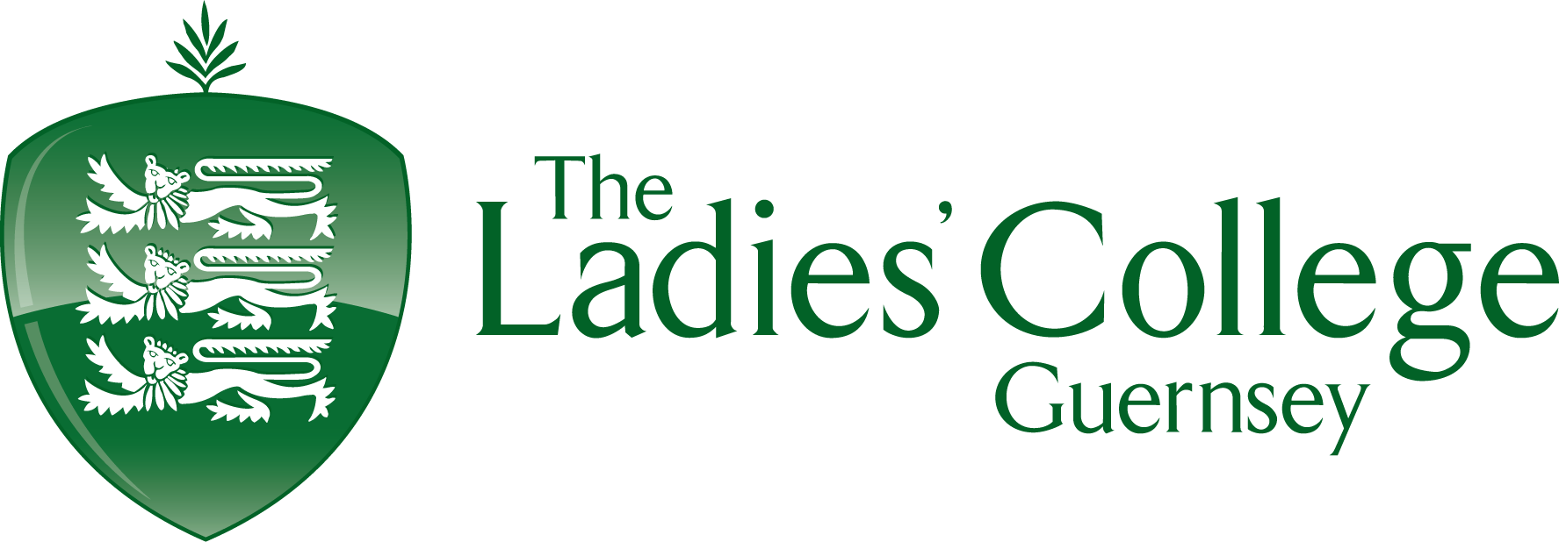
Clothing

Got it | Packed it | Equipment
 |  | Walking boots (Broken in)
 |  | Walking socks (plus spare pair)
 |  | T-shirts
 |  | Fleeces (Not hoodies or heavy jumpers)
 |  | Underwear
 |  | Warm hat
 |  | Gloves
 |  | Sun hat & Sunglasses
 |  | Waterproof/windproof jacket
 |  | Waterproof trousers
 |  | Warm nightwear (Thermals? Or consider leggings and a long sleeve top?)

Personal Kit

Got it | Packed it | Equipment
 |  | Rucksack (65 litres) (needs waterproofing with rucksack liner or thick bin sack)
 |  | Sleeping mat (in waterproof bag/bin sack)
 |  | Sleeping bag (2-3 season)
 |  | Wash kit & personal hygiene items
 |  | Towel
 |  | Small amount of toilet paper or wet wipes
 |  | Watch
 |  | Whistle
 |  | Torch (spare batteries)
 |  | Personal First Aid Kit (including personal medication)
 |  | Emergency rations (can be a snack and hot drink)
 |  | Water bottle (1-2 litres)
 |  | Knife, fork & spoon (or spork)
 |  | Plate / Bowl
 |  | Mug
 |  | Notebook & pen / pencil (for making notes for final presentation)
 |  | Sun cream
 |  | Food

Group Kit

Got it | Packed it | Equipment
 | Provided | Tent
 | Provided | Trangia Stove
 | Provided | Gas
 |  | Brillo Pad
 |  | Tea Towel
 |  | Plastic Bags (for rubbish etc)
 | Provided | Survival bag (for extreme weather recommended for Silver and Gold only)
 | Provided | Maps
 | Provided | Compass
 |  | Matches (in waterproof container)

Optional Extra Kit

Got it | Packed it | Equipment
 |  | Flip flops / Trainers (for camp)
 |  | Sleeping bag liner
 |  | Camera
 |  | Insect repellent
 |  | Spare boot laces
 |  | Shorts / Joggers

I would advise against packing valuable items such as iPad’s or iPod’s. We cannot take responsibility for the loss or damage to these items.

**Mobile phones are not permitted to be used on expeditions and should only be used in the event of an emergency.

