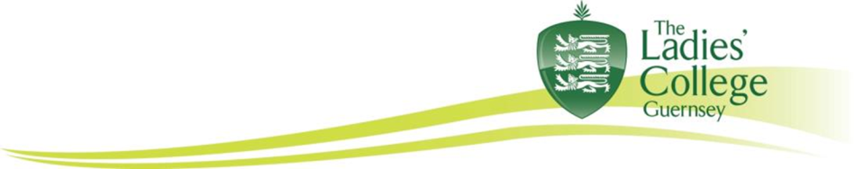
The Ladies’ College A–level results, summer 2015

We are delighted to report that students of The Ladies’ College who took A–levels this year have excelled once again.

Fifty-four students sat examinations this summer that will allow them to make choices and take decisions about their future. 40% of grades were A* and A, 70% A* to B and 89% A* to C.
An impressive twenty-four girls achieved at least ABB and twelve of our students scored straight A* and A grades. This is an outstanding achievement for all of the students and all at The Ladies’ College are delighted for the girls, who are successful academically whilst also demonstrating their interest, engagement, commitment and success through their breadth of experience inside and outside of College too.

Clementine Thompson’s straight A*s in Maths, Further Maths and Physics is particularly impressive, as not only has she been studying for A–levels this year, she has also led Brock House throughout the year to win the overall House Cup at Speech Day whilst also training and competing at sailing at international level. She will go to Edinburgh to study Maths in September, after she has competed in the Sailing World Championship in Canada, which is where she is today!

Other students who achieved A* and A grades are:

- Emma Brodrick who will go to Exeter to study Biological Sciences
- Lydia Cherry who was one of twelve students who successfully auditioned from 12,000 to be offered a place at the Arts Educational Schools in London
- Sophie Cowley who will study Economics and Geography at Birmingham
- Amy Fallaize who will study Psychology at Bath and will no doubt continue to excel at netball, as she excelled here as Head Girl
- Emily Green who will study Law at Sheffield in 2016 and who successfully led the School Council in 2014 – 2015, as well as being Guernsey’s Young Volunteer of the Year
- Eva James will study Languages at Durham and we hope she will continue to excel at singing
- Natalia Jopling-Tanser will study English at Southampton and we wish her luck as she attends the finals for the Institute of Directors Debate in London
- Phoebe Morgan and Anna Ogier will both study medicine at Bristol and have also achieved much outside of the classroom dancing, singing and playing the Flute to Grade 8
- Charlotte Parkes who is a true all – rounder and who will study Languages at Durham,
- Sam Sweeney who will apply to study medicine next year.

With almost nine out of ten results being A* to C, we wish all of our students every success as they embark upon the next chapter, hoping that they will stay in touch with The Ladies’ College. It is their attitude that underpins everything that they achieve and we look forward to issuing certificates in early January in College and once again celebrating their success.

ENDS

