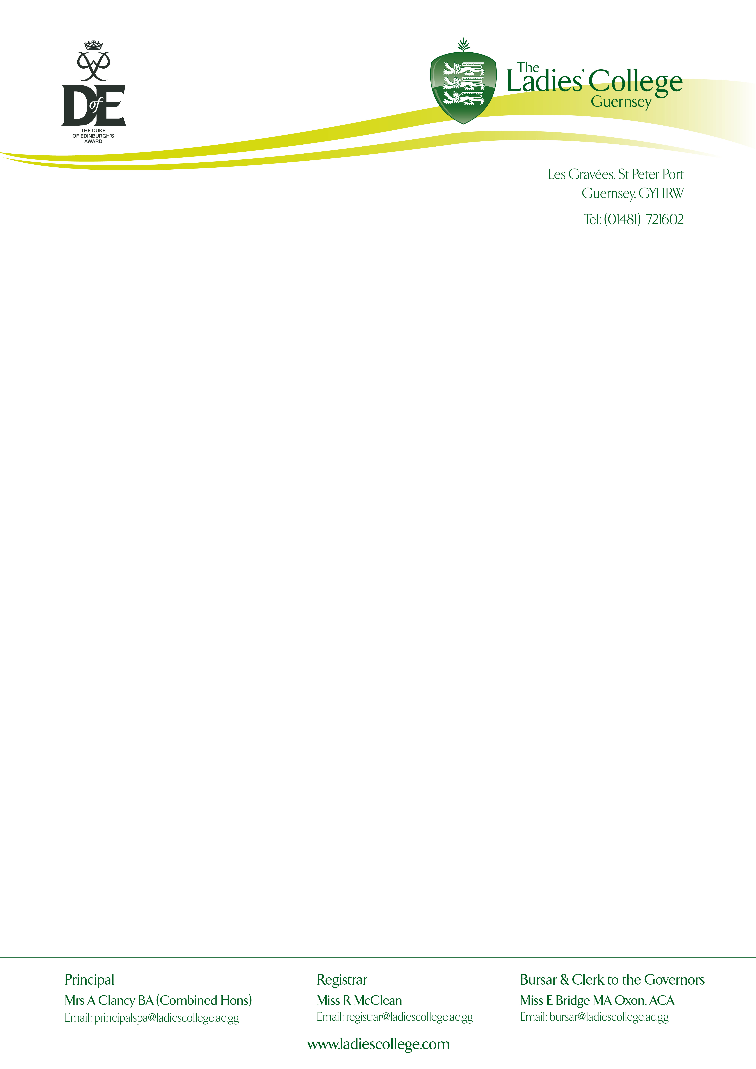

28th March 2019

Dear Parents & Students,

Gold & Silver Duke of Edinburgh’s Award – Meeting 5 – 6pm

We would like to invite parents and students to an informal pre-trip meeting on Monday 1st April at 5pm – 6pm in the main hall.

Your daughter will have the opportunity to collect a backpack and roll mat during this time should she need to borrow these items.

We look forward to welcoming you on Monday. If you are unavailable to attend, I would be happy to schedule a meeting with you, or alternatively I can email you the additional information.

In the meantime, if you need any more information please email me:
lmitchinson@ladiescollege.ac.gg

Yours sincerely

Miss L. Mitchinson (D of E Co-ordinator)
The Ladies’ College

My office hours are:
Tuesday 1-4
Thursday 09.30 – 4
Friday 09.30 – 1.30

