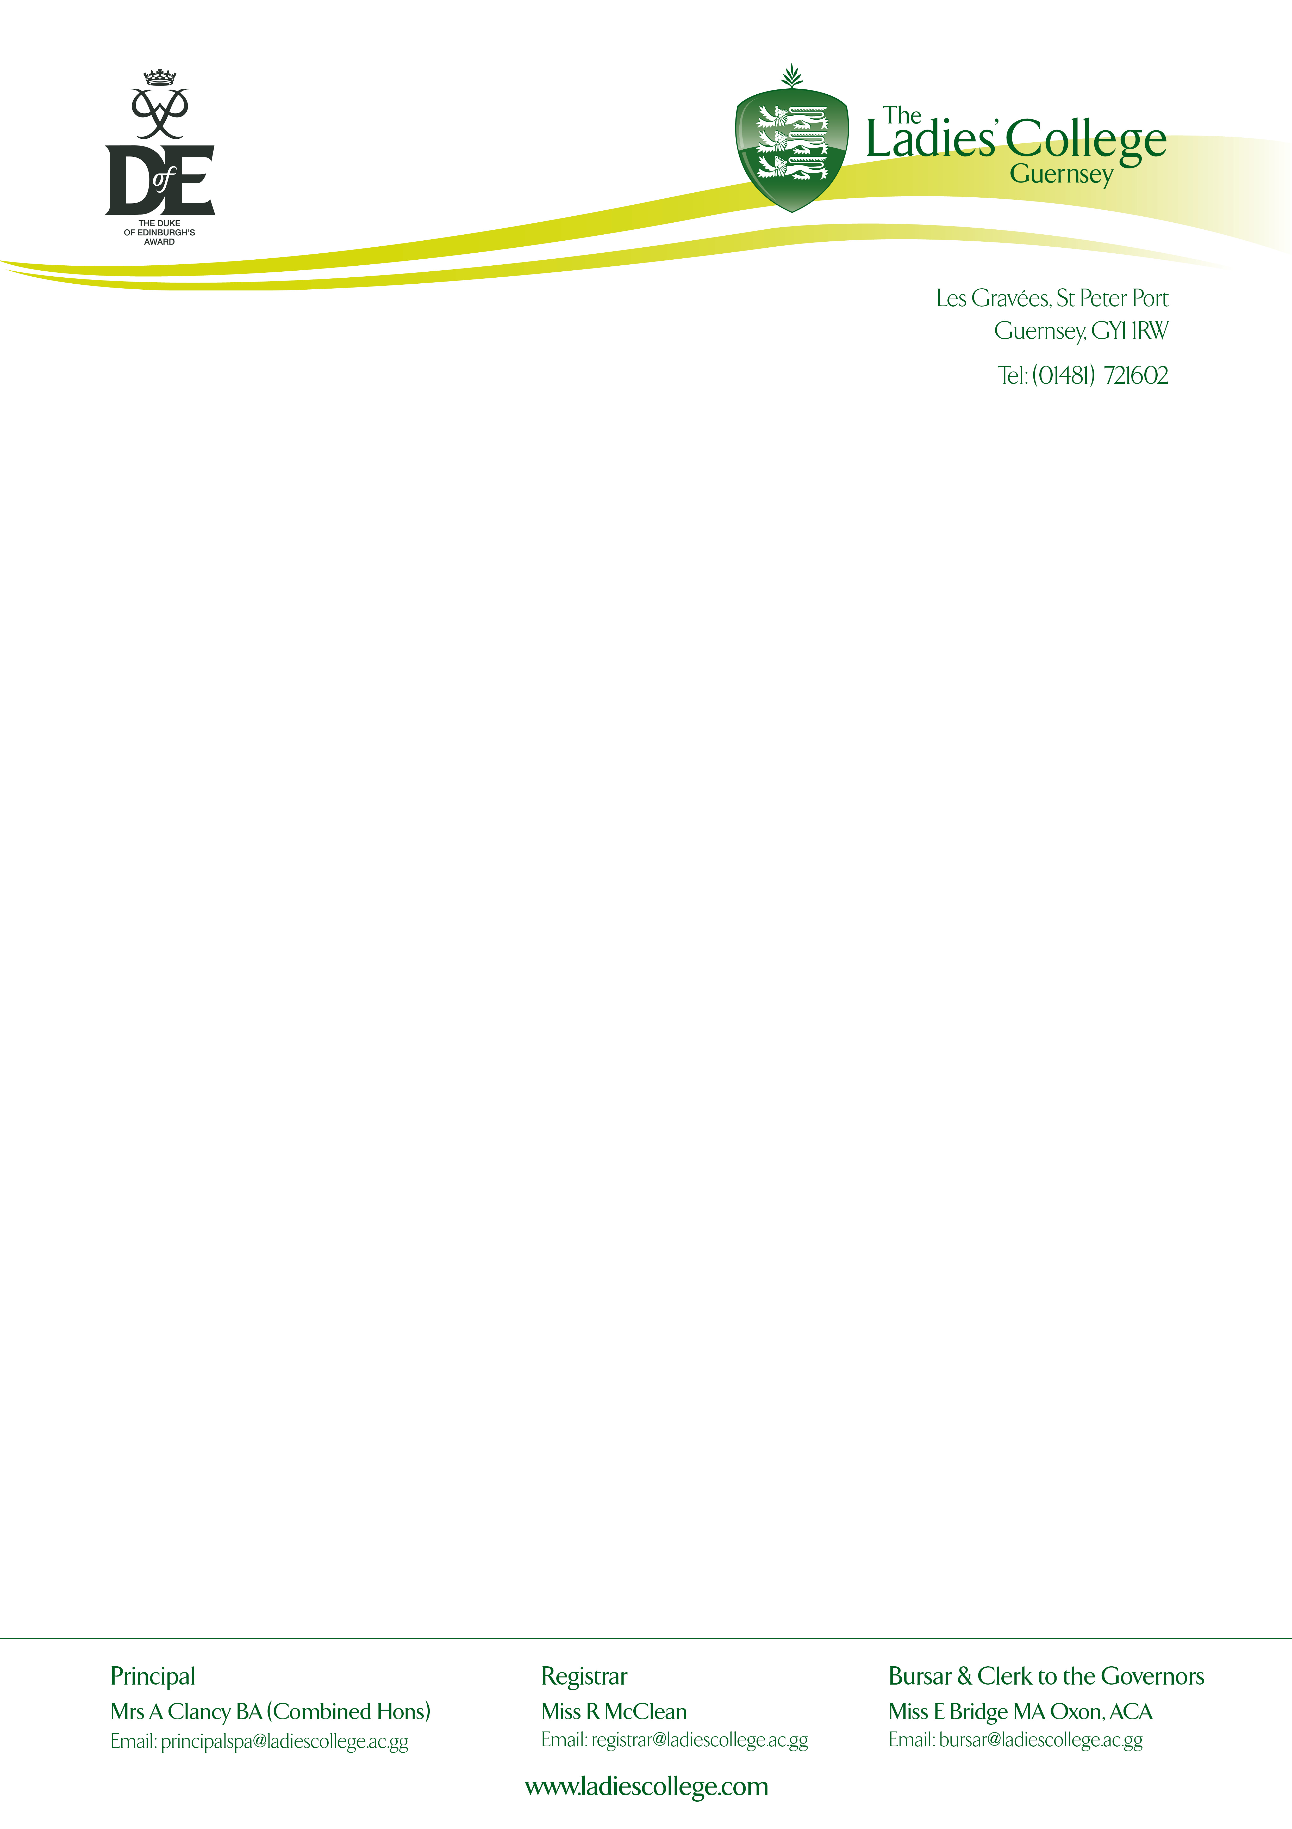

22nd March 2019

Dear Parents,

Silver & Gold Duke of Edinburgh’s Award – Practise Expedition 2019

We are pleased to provide further details regarding the forthcoming Gold and Silver Duke of Edinburgh’s Award Expeditions.

Details are as follows:
- Saturday 13th April - Depart Guernsey at 09.50 and fly to Manchester Airport.
- Sunday 14th April - Expedition Planning Day.
- Monday 15th April – Expedition Day 1.
- Tuesday 16th April – Expedition Day 2.
- Wednesday 17th April – Expedition Day 3.
- Thursday 18th April - Depart Manchester to Guernsey arriving at 20.50.

Please arrive at the Departures Terminal One Hour prior to the departure time at 08.50. Two staff members will be accompanying all students on both outbound and returning flights. Backpacks will be checked in, and therefore students will need a small bag with personal items and spending money for the airport and transfer to Hathersage.

FAQ

Where can I buy food and snacks?
There will be plenty of opportunities for the students to visit the shops and cafes of Hathersage/Castleton for stocking up on snacks and to have lunch and dinner.

Shall I bring all my expedition food with me?
Expedition meals (boil in the bags) can be purchased in the local camping shops. The price doesn’t vary greatly from Guernsey prices, and there is plenty to choose from. Alternatively, you can purchase all these beforehand and bring them with you. Just be mindful of the additional weight these will add to your bag for the flight. Dehydrated boil in the bag meals are a little more expensive, but reduce the weight considerably.

Where do I put all my other belongings during the expedition?
You will have a chance to re-pack your backpacks before you depart on expedition. Any additional clothing or items you don’t need on expedition will be packed away and stored for you at the Adventure Expeditions office. You will collect these when you finish your expedition. Any valuables will be stored here also.

What group kit do we need?
Tents, trangias, gas, maps, waterproof map cases, group shelters, group first aid kit and expedition safety cards will be provided by Adventure Expeditions, and so students will not need to bring these with them.

What personal kit do I need?
All participants are to provide their own suitable personal kit for a Silver or Gold Expedition. We do have backpacks, roll mats, sleeping bags and a limited number of waterproofs should your daughter need to borrow these from College. A full kit list has been attached. It’s a great guide and covers everything you should need to make it a comfortable and enjoyable few days. If you suffer from the cold, be sure to pack the correct warm layers, and spare dry clothing should you get wet.

Pre-trip meeting
This will be scheduled for one evening before the end of term. We will write to you in due course with dates and times.

I have also attached an itinerary of the trip for your information.

Please do not hesitate to contact me should you require further information.
lmitchinson@ladiescollege.ac.gg

Yours sincerely,

Miss L. Mitchinson (D of E Co-ordinator)
The Ladies' College

-Kit list attached
-Itinerary attached

