Ladies’ College

Information and Communications Technology

User Guide
Office 365 OneDrive App

iPhone & iPad

- If you don’t have OneDrive for Business installed, download it from the App Store
https://itunes.apple.com/us/app/skydrive-pro-for-office-365/id655772279

- Type in your Ladies’ College email address and password and tap sign it.
You now have access to all the files saved in OneDrive
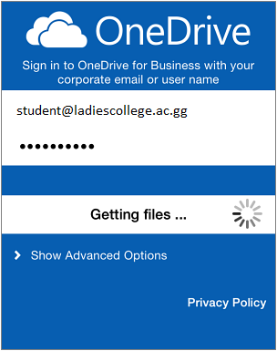

- To open files tap any document to open it.
You can only view documents using one drive for Business App. If you want to edit a Word, Excel, Powerpoint, or OneNote file from your iPhone or iPad you need to install Office on an iPhone or iPad

- Word - https://itunes.apple.com/app/id586447913
- Excel - https://itunes.apple.com/app/id586683407
- PowerPoint - https://itunes.apple.com/app/id586449534

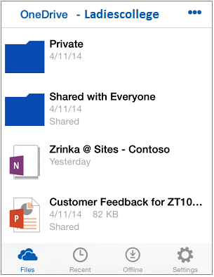

Share Files – Tap the file you want to share. When the file opens, tap
Get More Help – Tap Settings Online help to learn more about using this app.

Android Phones & Tablets

- If you don’t have OneDrive installed download it from the Google Play store
https://play.google.com/store/apps/details?id=com.microsoft.skydrive

- Open the app and tap Sign in. Add your Ladies’ College email address and password.

- Tap Menu to see your account, and then tap Files to see the documents you saved in OneDrive.
Tap any document to open it. You can only view documents by using the OneDrive app. If you want to edit a Word, Excel, Powerpoint and OneNote to your Android phone or tablet.

Word - https://play.google.com/store/apps/details?id=com.microsoft.office.word
Excel - https://play.google.com/store/apps/details?id=com.microsoft.office.excel
Powerpoint - https://play.google.com/store/apps/details?id=com.microsoft.office.powerpoint
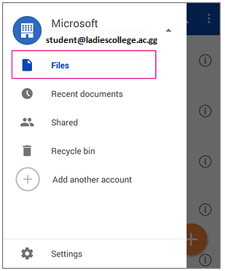

Add photos or videos

- Choose where you want to upload the pictures to
- Tap Upload , and then tap Upload photos and videos

Windows Phones

When you add your Office 365 Ladies College username and password to your Windows phone, OneDrive is automatically add to the Office app. If you have not done so yet follow these instructions.

- In the App list, tap Settings> email+account> add an account. Select the account type.
- Type your Ladies’ College email address and password.
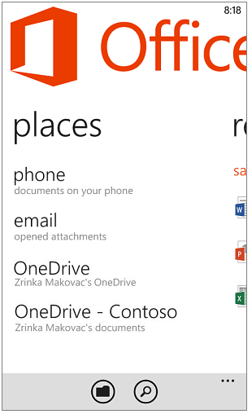
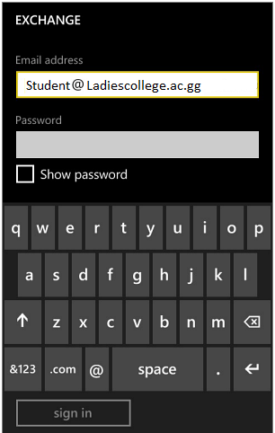
Tap Office app > Places
Tap OneDrive - <Ladies College> to see documents you saved in OneDrive.
Tap any Word, Excel, PowerPoint or OneNote document to open it.

To share a documents:-
Open the document and tap More > Share
Tap the email account you want to send the message from, type your message and then tap Send.

